Photo |  | PHOTO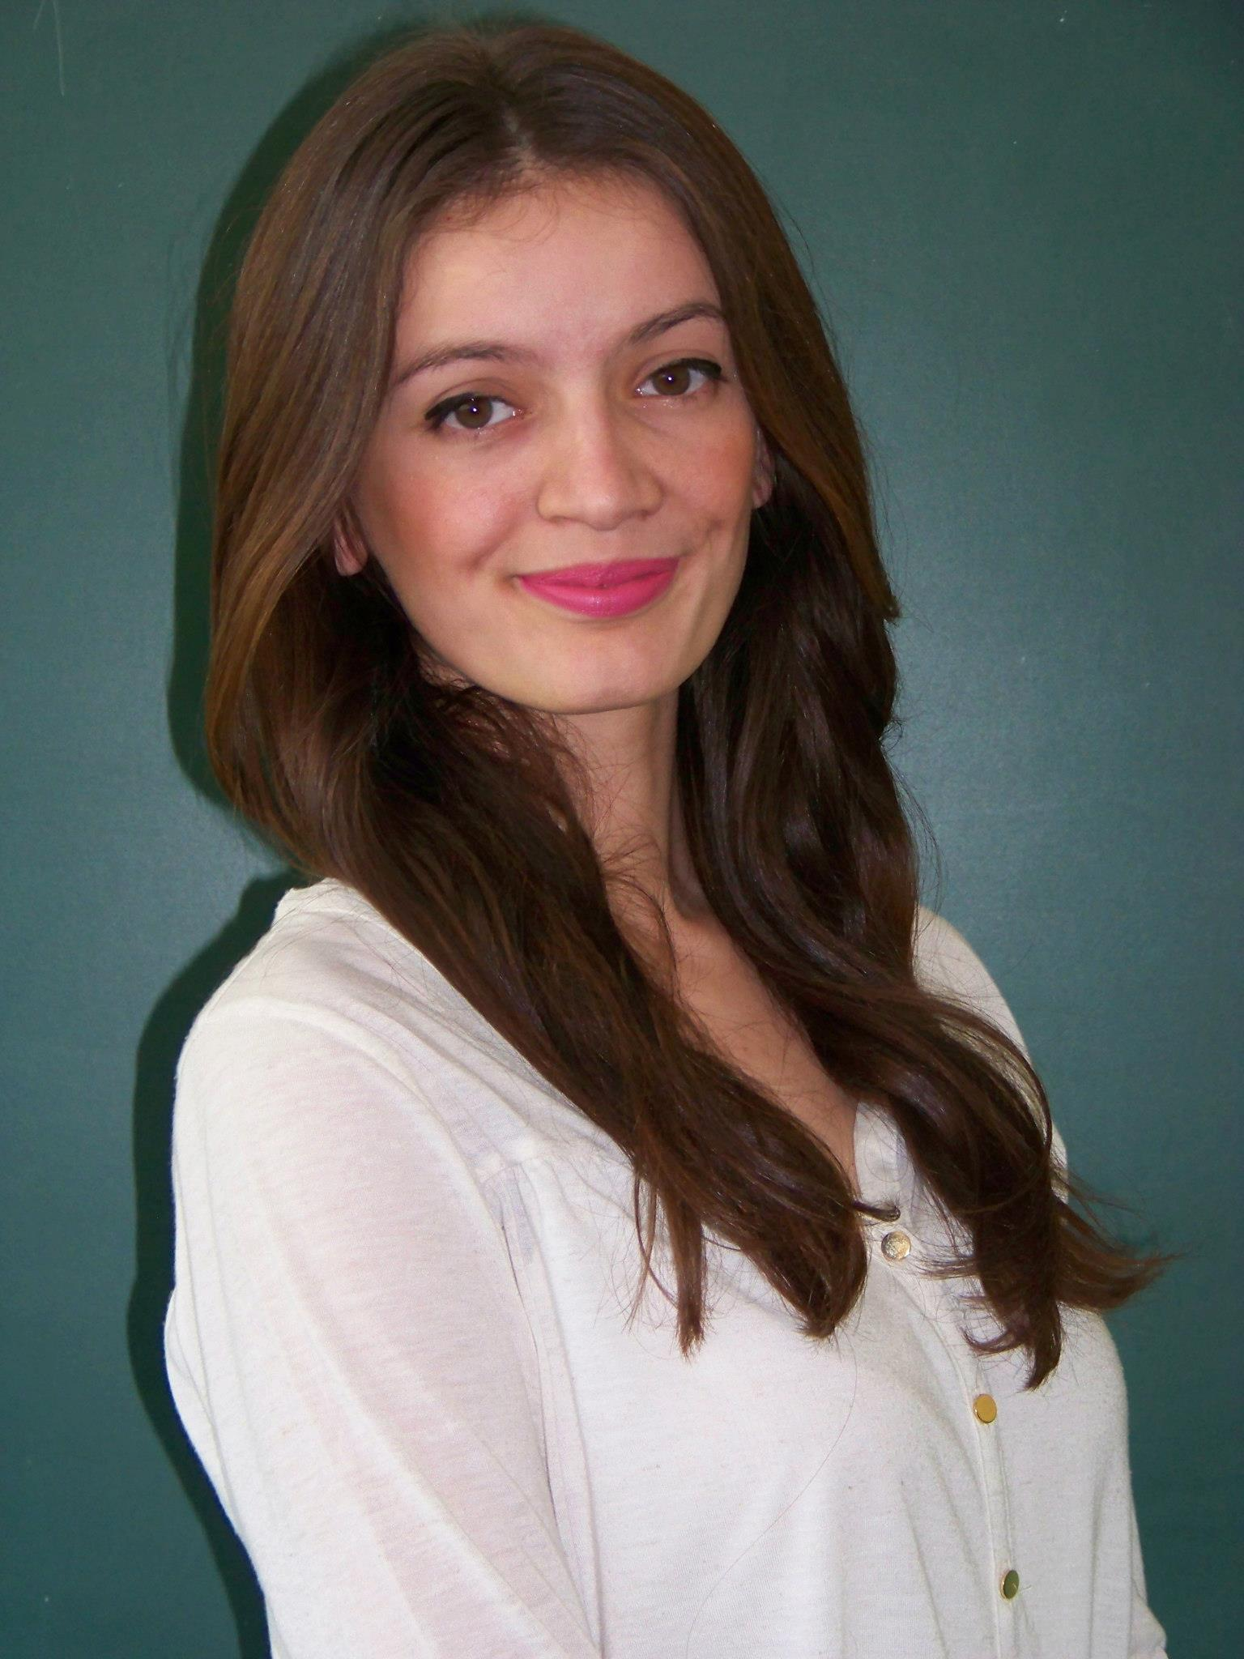
Europass
Curriculum Vitae
Personal information
First name / Surname |  | Vildane Maliqi
Address |  | Skenderbeu Street #21, 10000 Kamenicë , Kosovo
Telephone(s) |  |  |  |  |  |  | Mobile: |  |  |  | +377 45 523 603
E-mail |  | vildanemaliqi@hotmail.com
Nationality |  | Albanian
Date of birth |  | 27.10.1994
Gender |  | Female
Work experience
Dates |  | 14.04.2009-14.06.2012
Occupation or position held |  | Moderator at the Radio Kamenica ,Vice president at the nongovernmental organisation AURA and head of LYAC
Main activities and responsibilities |  | Present different stories that worries our youth here in Kamenica  Organize competition among schools to challenge their knowledge  Make the technical thing that fulfield the meaning of leading a nongovernmental organisation  Collaborate with the KFOR soldiers on the different events that we present on the Radio  To held meetings when the Albanian and the Serbian youth could create a mosaic of the future  To make the agenda about what the LYAC (local youth active council ) has to do about one year period  To create better opportunities for the youth by sharing and searching for the scholarship programs in the universities in Europe
Name and address of employer |  | Kamenica st “Skenderbeu “,Prishtina “Nena Terezë”
Type of business or sector

Dates
Occupation of position held

Main activities and responsibilities

Name and address of employer

Type of business or sector

Education and training
Dates  Title of qualification awarded  Principal subjects/occupational skills  covered  Name and type of organisation providing education and training  Dates |  | 2013-Finished  Graduated from High school  High school “Ismail Qemali”  2010-2013  Organisation “Aureola”  2009 -2010-2011
Title of qualification awarded |  | Red cross volunteer
Principal subjects/occupational skills covered |  | Red cross in Kamenica
Name and type of organisation providing education and training |  | EYP  European youth Parliament
Dates  Title of qualification awarded  Name and type of organisation  providing education and training |  | 2012, 18-21 october  Delegate at the second conference  Prishtina, Kosovo.
Personal skills and competences
Mother tongue(s) |  | Albanian
Other language(s) |  | English,
Self-assessment |  |  | Understanding |  |  |  |  | Speaking |  |  |  |  | Writing
 |  |  | Listening |  | Reading |  |  | Spoken interaction |  | Spoken production
English |  |  |  | Proficient user |  | Proficient user |  |  | Proficient user |  |  | Proficient user |  | Proficient user
Serbian |  |  |  | Proficient user |  | Proficient user |  |  | Proficient user |  |  | Proficient user |  | Proficient user
Social skills and competences |  | Maintaining a presence of willingness and comfort ability so as to be a part of the solution and not part of the problem. Being socially affable and approachable. Remaining committed to the mission regardless of personal issues. Very confident in my ability due to history, and education, to constructively complete my assigned mission responsibilities.
Organisational skills and competences |  | Remain committed to priority selection of matters with respect to timelines and the organization required to effectively manage my time in balance with what must be done when and how
Computer skills and competences |  | Competent with most Microsoft Office programmes, lotus notes and networking
Driving licence |  | “B” Category
Additional information |  | I am a student of architecture in UBT University in the secon yeard and my average is 9.5
Annexes

